

Practices for Secure Software Report

Table of Contents
Document Revision History 3
Client 3
Instructions 3
Developer 4
1. Algorithm Cipher 4
2. Certificate Generation 4
3. Deploy Cipher 4
4. Secure Communications 4
5. Secondary Testing 4
6. Functional Testing 4
7. Summary 4
8. Industry Standard Best Practices 4

Document Revision History

Version | Date | Author | Comments
1.0 | [04/18/26] | [Lawrence Langelier]

Client



Instructions

Submit this completed practices for secure software report. Replace the bracketed text with the relevant information. You must document your process for writing secure communications and refactoring code that complies with software security testing protocols.

- Respond to the steps outlined below and include your findings.
- Respond using your own words. You may also choose to include images or supporting materials. If you include them, make certain to insert them in all the relevant locations in the document.
- Refer to the Project Two Guidelines and Rubric for more detailed instructions about each section of the template.

Developer
[Lawrence Langelier]

Algorithm Cipher

[For Artemis Financial, I recommend using the Advanced Encryption Standard (AES) with a 256-bit key, commonly known as AES-256, along with SHA-256 for checksum verification. AES is a symmetric encryption algorithm, meaning the same secret key is used to encrypt and decrypt data. It is widely trusted, highly efficient, and commonly used to protect sensitive financial and personal information. Since Artemis Financial handles customer savings, retirement, insurance, and investment data, strong encryption is necessary to protect confidentiality during storage and transmission.
AES-256 uses a 256-bit key length, which provides a very large number of possible key combinations and makes brute-force attacks impractical with current technology. For data integrity, SHA-256 can be used as a hash function to generate a checksum. A hash function takes data and produces a fixed-length value that changes if the original data is modified. This allows the company to verify that files or transmitted information were not altered. Random numbers are also important in modern encryption because they are used for secure key generation, initialization vectors, and certificate creation. AES is a symmetric-key algorithm, while HTTPS also uses asymmetric encryption through public and private keys during the TLS handshake to securely exchange keys. Older encryption standards such as DES became outdated due to weak key lengths, while AES remains the modern industry standard and is approved for protecting sensitive information today.
]

Certificate Generation
Insert a screenshot below of the CER file.

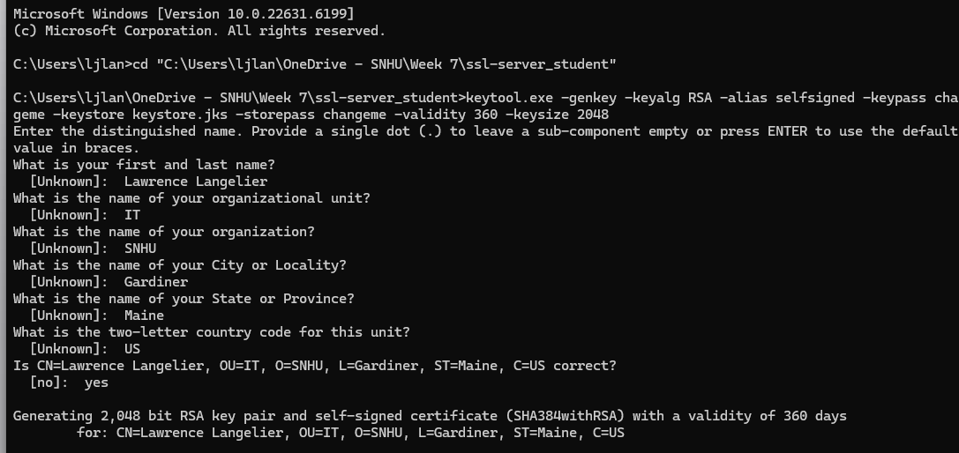

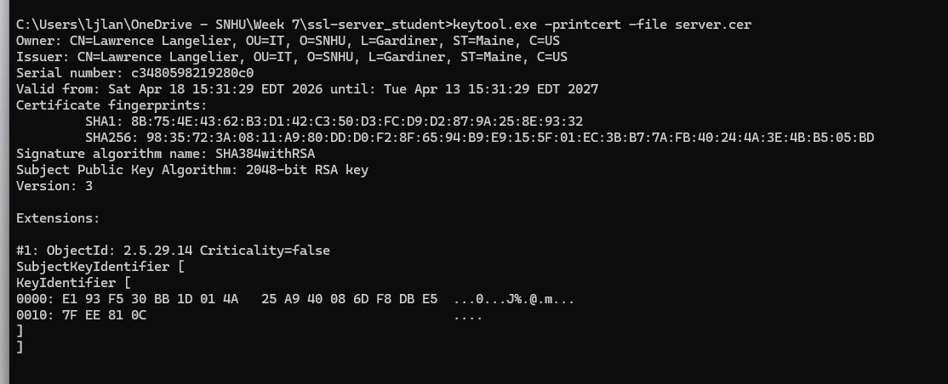
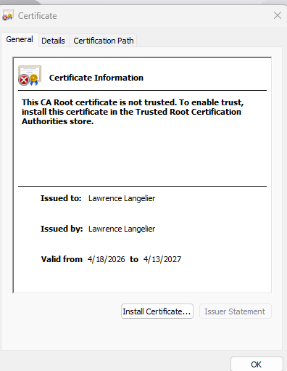
I generated a self-signed certificate using the Java Keytool utility. The certificate used a 2,048-bit RSA key pair and was stored in a Java keystore file. After generating the certificate, I exported it to a server.cer file and used the print certificate command to verify the certificate details. The output confirmed the owner, issuer, validity dates, fingerprints, and encryption algorithms. This process demonstrates how certificates can be created and used to support secure HTTPS communication during software development.
]

Deploy Cipher
Insert a screenshot below of the checksum verification.

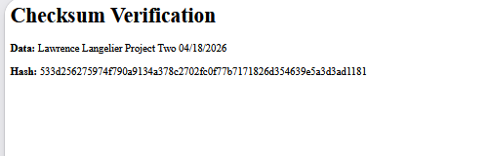

I deployed and implemented a cryptographic hash algorithm by refactoring the application to use SHA-256 checksum verification. A new route was added to the software that processes a unique data string containing my name and project information. The Java MessageDigest class was used to generate the hash value. After running the application, I verified the checksum through the browser, where both the original data and generated hash were displayed successfully.]

Secure Communications
Insert a screenshot below of the web browser that shows a secure webpage.

[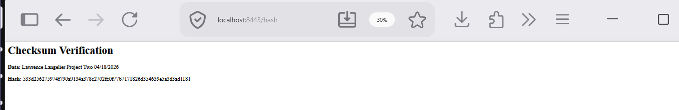

I verified secure communication by configuring the application to use HTTPS with an SSL keystore in the application.properties file. The server was configured to run on port 8443 using a self-signed certificate created with Java Keytool. After launching the application, I accessed the secure route using https://localhost:8443/hash. The browser successfully loaded the page and displayed the checksum verification content, confirming that encrypted HTTPS communication was enabled and working properly.]

Secondary Testing
Insert screenshots below of the refactored code executed without errors and the dependency-check report.

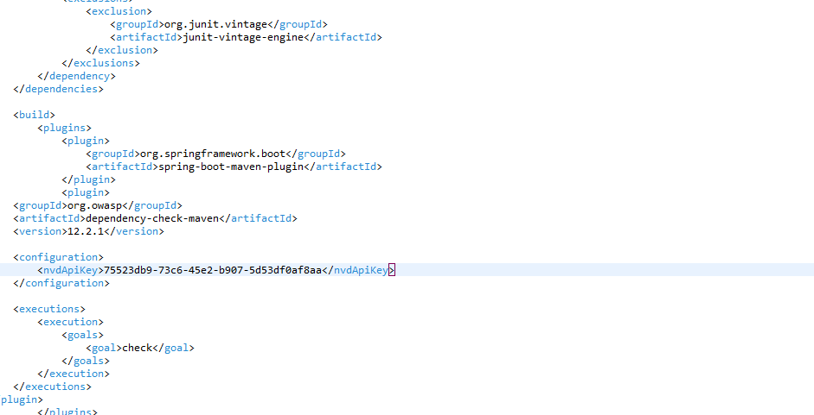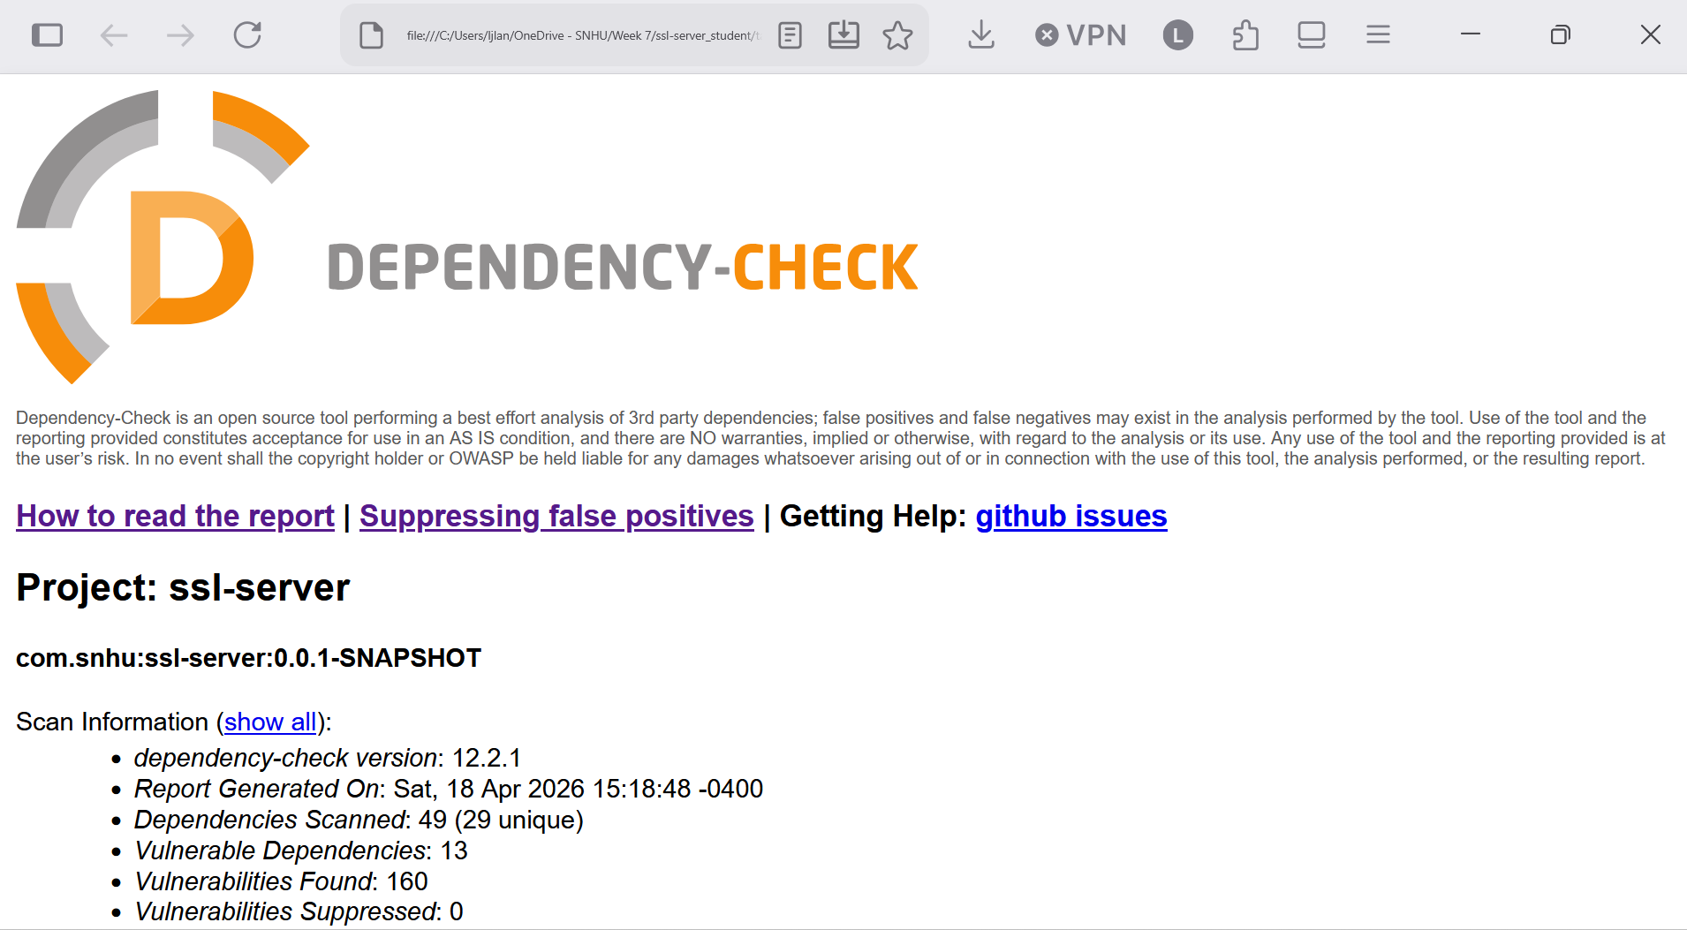

I completed secondary static testing using the OWASP Dependency-Check Maven plugin. The scan successfully analyzed the project dependencies and generated an HTML report for the ssl-server application. The report identified known vulnerabilities in several older third-party libraries, which demonstrates that the security scanning tool was functioning properly. I also verified that the refactored application executed successfully after the security changes were implemented. This testing helped confirm that the project remained operational while identifying additional areas for future improvement.

Functional Testing
Insert a screenshot below of the refactored code executed without errors.

I completed functional testing by manually reviewing the software application for syntactical, logical, and security vulnerabilities. During testing, I corrected syntax and structure issues in the Java source code to ensure the application compiled properly. I reviewed the program logic to confirm that the /hash route returned the expected data string and successfully generated a SHA-256 checksum. I also manually reviewed and corrected the application.properties configuration file by replacing placeholder values with the proper HTTPS settings, including the SSL keystore alias, password, file path, port number, and keystore type. After these corrections were made, the refactored application executed without errors and successfully loaded through HTTPS on port 8443. These results confirmed that the software was functioning properly after the refactoring process.



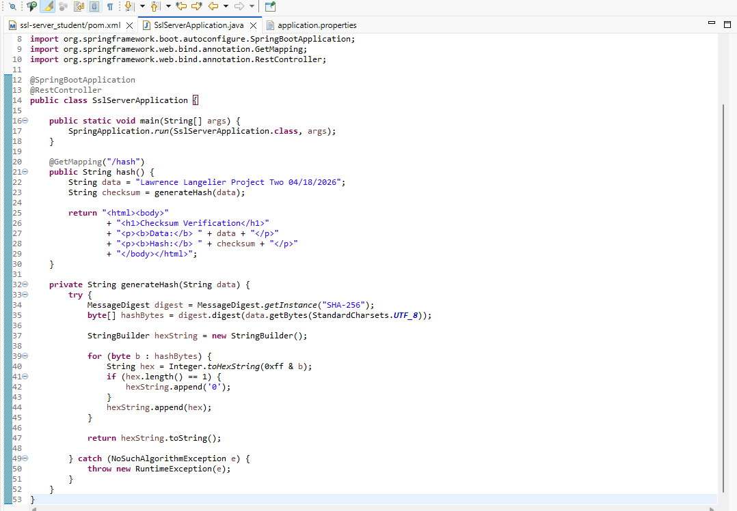

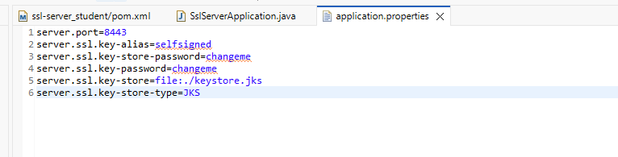

Summary

[I refactored the Artemis Financial software application by adding multiple security improvements and verifying that the updated code complied with security testing protocols. Using the vulnerability assessment process flow as a guide, I focused on several important areas of security, including cryptography, client/server security, code quality, input and output handling, and overall secure configuration. I implemented a SHA-256 checksum feature to help verify data integrity during communication, which strengthened the cryptography portion of the application. I also configured HTTPS with a self-signed SSL certificate to secure data transmitted between the client and server. In addition, I reviewed the Java source code and configuration files to correct errors and ensure the application functioned properly after refactoring.
My process for adding layers of security involved using a defense-in-depth approach rather than relying on only one control. First, I added encryption through HTTPS to protect data in transit. Second, I added checksum verification to help detect unauthorized data changes. Third, I used OWASP Dependency-Check to scan project dependencies for known vulnerabilities and identify outdated libraries that may need updates. Finally, I performed manual functional testing to verify that the application launched correctly, the /hash route worked as intended, and secure communication was successful. By combining encryption, integrity checks, automated scanning, and manual testing, the software application now has stronger overall protection.
]

Industry Standard Best Practices

[I applied industry standard best practices for secure coding by strengthening the application without removing its original functionality. I maintained the software application’s existing security by keeping the core Spring Boot structure in place while adding protections that are widely accepted in professional development. These practices included using HTTPS to encrypt communication, generating and using a self-signed certificate for secure testing, implementing SHA-256 hashing for checksum verification, and running OWASP Dependency-Check to identify known vulnerabilities in third-party dependencies. I also manually reviewed the Java source code and configuration files to correct issues that could have prevented secure operation. This approach helped preserve the application’s original purpose while improving its security posture.
Applying industry standard best practices is valuable to the company’s overall well-being because it helps protect sensitive customer and financial information, lowers the risk of data breaches, and improves trust in the software. Secure coding practices also make vulnerabilities easier to detect earlier in development, which can reduce long-term costs and prevent larger problems later in production. For Artemis Financial, these best practices support confidentiality, integrity, and secure communication, all of which are especially important when working with personal financial data. By using established security methods instead of relying on weak or outdated protections, the company is better positioned to maintain reliable service, meet customer expectations, and reduce future security risks.
.

